Request for Information (RFI)

Outline concept for end to end small satellites multipurpose solutions in response to national and European needs

Date of Issue 28/06/2021

Table of Contents
1. INTRODUCTION AND CONTEXT 3
2. MISSION STATEMENT AND REQUIREMENTS 4
2.1. Mission Statement 4
2.2. Main Mission Requirements 4
2.3. Technology Elements 4
3. RISK SHARING AND SYNERGIES 4
4. INDUSTRIAL ORGANISATION 5
5. SUBMISSION AND EVALUATION 5
5.1. General 5
5.2. Submission template 5
6. ENVISAGED NEXT STEPS 7
APPENDIX A: Preliminary User/Data Requirements 8
APPENDIX B: Small Sat 8
APPENDIX C: Additional Info 9

INTRODUCTION AND CONTEXT
In the new digital age, connectivity is now a key prerequisite for the digital transformation of states, as the expected economic and social benefits will only be achieved if states ensure the widespread deployment of networks and the provision of very high capacity services throughout their territory. Space is an enabler for the digital transformation.
The Ministry of Digital Governance develops and implements the national space policy, strategy and plan. It represents the country in all European and international organisations including European Union Space Programme Agency (EUSPA), European Space Agency (ESA), International Telecommunications Union (ITU) as well as in other European or International Organizations with focus in Space related activities.
The national strategy for space is pivoting around four objectives:
- Strengthen national security and defense, especially with the utilization and development of space infrastructure. Ensure national autonomy in safety and security (e.g border control, disaster management) by enhancing existing infrastructures (e.g. GreekCom) and developing new ones (e.g small satellites). The goal is to autonomously respond to national safety and security needs.
- Development of the Greek space industry. Maximise the integration of Greek companies into the European industrial space landscape. The goal is to create a sustainably competitive Greek space industry.
- Utilise of space data and the development of relevant applications. Foster the integration of space into the society and economy, by facilitating the use of space technologies and applications to support public policies and business development (e.g. telecom, transport, maritime, agriculture, energy, environment). The goal is to create public and commercial services.
- Support space research and innovation.
The related strategies are:
- Development of a national small sat. Achieving autonomous capabilities to respond to national needs, strengthening the Greek industry competitiveness with the possibility for commercial utilisation in the global market.
- Flight heritage. Achieving flight heritage though the EU, ESA and national programmes by maximising technological and financial synergies.
- Ground infrastructure. Utilising and further developing existing infrastructures: nationally or privately owned stations (e.g Tanagra, Koropi, Ag. Paraskeui), telescopes, lasers, radars, etc
- User alignment (ministries). Supporting through space the development implementation and monitoring of sectorial policies (e.g. telecom, transport, maritime, agriculture, energy, environment, safety and security)
- Exploit data of existing infrastructure. Opening of public information will increase the size of the domestic market, especially when the private and the public sector work together. In navigation Galileo will boost commercial activities and integrated applications will tie Earth Observation and navigation to telecommunications.
The widespread of digitisation of the economy and society require “anything, anytime, anywhere” connectivity across national and European territories.
Since 2019 Greece has its own operational Governmental Satellite Communication (GovSatCom) system called GreeCom. The system is based on Hellas Sat 3 and 4 and the Satellite Distribution Centre (HUB) of GreeCom is installed in the Ministry of National Defence establishments. Operations are exclusively conducted by the Ministry of National Defence personnel. The system is connecting in a reliable and resilient manner decision centres (e.g President of the Republic, Prime Minister, Ministers, General Secretaries, Emergency Operation Centres (civil protection, fire brigade, coast guard), Hellenic Diplomatic Network, National Defence) (see Annex B).
On 4 December 2019, Greece though the Ministry of Digital Governance became signatory of the European Union Quantum Communication Infrastructure (EuroQCI) initiative. The EU Member States have committed to working together, with the European Commission (EC) and the European Space Agency (ESA), towards the development and deployment within the next ten years of a secure quantum communication infrastructure (EuroQCI) – to enable public administrations to transmit and store information and data ultra-securely, and to safeguard critical infrastructure and encryption system across the EU. EuroQCI will link sensitive public and private communication assets all over the EU, using quantum technologies to ensure the secure transmission and storage of important information. The EuroQCI would be made up of two elements: one based on earth, making use of existing fibre communication networks linking strategic sites throughout the EU, and the other based in space, to enable coverage of long distances across the EU and other continents. It would secure sensitive governmental communications, financial transactions and the long-term storage of sensitive data in areas like health, national security and defence. In this framework, the national QCI called GreeQCI is currently under preparation (Annex C).
The European Union is currently developing its next space flagship programme in the field of connectivity, following the announcement of Commissioner Breton on 15 July. The Commissioner stated that “… we already need to look beyond 5G. I am talking about starting to prepare for 6G of course, but not only. The next paradigm shift is about linking connectivity with space to provide high-speed connectivity everywhere in Europe”. The European Union has the ambition to invest in the development of a new integrated, secure and autonomous space connectivity system, that would complete the EU’s capacity, along with the EU’s world leading satellite navigation and Earth Observation system, Galileo and Copernicus. The European Commission is planning to develop this flagship of “European Secure Connectivity Initiative” by bringing together existing programmes and activities of the Commission, the European Space Agency and the Member States and planning new ones. In particular, is expected that space and terrestrial infrastructures are interconnected in order to provide:
- high speed broadband availability throughout the territory of the European Union, removing dead zones and ensuring cohesion across Member States;
- resilient, secure and cost-effective governmental communication services, that support protection of critical infrastructures, surveillance, external actions and crisis management, possibly including those based on quantum technologies,.
On 12 January Commissioner Breton stated that “Europe needs to develop rapidly an space based connectivity initiative as a third infrastructure besides Galileo & Copernicus. With this infrastructure, we will:
- put an end to dead zones, giving access to high speed broadband to everyone;
- become autonomous and avoid dependence on the non-EU initiatives under development, like we did with Galileo;
- project Europe into the quantum era, ensuring quantum encrypted communication;
- keep the continent connected whatever happens, including massive attacks on the internet, which are no fiction anymore, especially with the emergence of the quantum computing capacities”
“This project is designed as a multi-orbital initiative, combining LEO infrastructures with others, including GEO. It will complement our existing infrastructures, creating synergies. For instance, it will enhance the Galileo signal (making it able to withstand various potential interferences), provide to Copernicus data relay capacity for real-time missions, or host extra payload space-based sensors to perform Space Surveillance and Tracking directly from space.”
On 23 February 2021 in the Action Plan on Synergies between civil, defence and space industries, the EU space-based global secure communications system is described as “This flagship project aims at providing access to high-speed connectivity through a multi-orbit space infrastructure, including low earth orbit satellites, and complementing Galileo/EGNOS and Copernicus as the third EU satellite system., By integrating quantum encryption technologies, it will ensure highly secured connectivity and communication for governmental and commercial services (e.g. better connecting key infrastructure, supporting crisis management, surveillance and potential mass-market broadband applications). It will enable access to high-speed connectivity for everyone in Europe, and provide a resilient connectivity system allowing Europe to remain connected whatever happens, including large-scale cyber-attacks on the internet. Finally, it will be a geostrategic infrastructure at the centre of specific partnerships, for instance with Africa.”
The European Secure Connectivity Initiative is expected to build on the Govsatcom component of the EU Space Programme (which will provide the initial core of the available services though the pooling and sharing of existing satellite capacity) and a new space segment (based on a multi-orbit constellation) will be developed to complement such preliminary services. The new space segment will offer advanced connectivity capability and will feature the innovative quantum technology build though the EuroQCI initiative. A number of ESA activities are also running that relate to this initiative under the ARTES Programme e.g. Scylight/Hydron/SAGA, 4S, 5G.
In September 2020, the European Space Agency (ESA) selected Aristarchos Telescope of Helmos Observatory of that National Observatory of Athens as Optical Ground Station (OGS) to be used under the ARTES Scylight/Hydron/SAGA programme and is expected to be deployed at the end of 2021. It will also be utilised as OGS under the EuroQCI. The Aristarchos Telescope of Helmos Observatory is the largest telescope of southeastern Europe. Additionaly, two more telescopes have been selected as OGS in the north (Cholomondas telescope) and the south (Skynakas telescope) of the country to be included.
In December 2020, the Digital Transformation Strategy 2020-2025 is published which includes the strategy of Greece to use space as an enabler for digital transformation. It lists dedicated space related priorities and actions (Annex D) including the Micro-Satellite Project. This project is an important step for the implementation of the strategy of Greece for the utilisation of space technologies and applications and their uptake in the National economy. It includes the development of a microsatellite constellation that will cater application for telecommunications and earth observation for their use in governmental satellite services, cartography, maritime, precision agriculture, topography, and urban planning aiming at the development of innovative integrated applications’ services. The micro-satellite project is designed to be using the Fibre in the Sky – ESA HydRON, with target the holistic provision of secure telecommunication services. Additionally, the project of microsatellites will support the application and services for search and rescue, border control, national security, civil protection. The development of the microsatellite system (space and ground) is expected to strengthen the capabilities of the Greek high tech industry. The project is expected to increase the availability, security and authentication of governmental communication networks. In parallel, it will provide high speed connectivity in remote areas taking into consideration of CSR 3 to 2020. Additionally, the framework of development of the micro-satellites is envisaged to be part of the EU GovSatcom, EuroQCI and Connectivity announced by the European Union on 15 July 2020 and in the 23 February Action Plan on Synergies between civil, defence and space industries.
The purpose of this Request for Information (RFI) is to collect information from industry for an outline end to end small satellite (see Appendix B) solution as part of the European Secure Connectivity Initiative of Commissioner Breton and in response to national needs. It is part of the plan for the implementation of the development of a national small satellite constellation in response to EU and national strategic objectives and needs. This Request for an Outline Concept is open to entities residing in Greece or in the European Union or in Member States of ESA.
Important note: All information requested and provided in the frame of this Request will be used for information and planning purposes only and is not part of a procurement process. This Request does not bind the Ministry to any present or future procurement actions nor does it create any rights for respondents in relation to any present or future national or ESA or EU procurements.

MISSION STATEMENT AND REQUIREMENTS

Mission Statement
The mission statement is:
To develop, manufacture, put in orbit and operate a constellation of intelligent small satellites capable to host multipurpose and multiple payloads in response to European and national needs primarily for connectivity and secondary for the provision of multipurpose services (e.g. connectivity/telecommunications, video streaming for border surveillance and/or forest fire monitoring) while promoting the development of national industry and utilising national assets (e.g. Helmos OGS, GreeCom).

Main Mission Requirements
MIS-01 Use a hypothetical scenario and related user requirements of choice and propose an end to end mission concept for a constellation of intelligent small satellites capable of hosting multipurpose and multiple payloads. The primary payload in all small satellites shall be for connectivity/telecommunications (Ku, Ka, Q/V bands to be considered) with on board IP routing capabilities, optical intersatellite links between the small satellites and RF (Ku and Ka) intersatellite links with GEO satellite. The secondary functionality of the payloads will be used for the development of innovative integrated applications’ services, such as 24/7 on demand in-orbit video coverage (e.g visible, hyper-spectra) of the planet. Components of the shelf (COTS), telecommunications protocols (including terrestrial), standardized interfaces, high speed data exchange, etc are to be utilised and identified.
MIS-02 Propose scenarios where the mission concept of choice for the constellation will be part of the building block of the European Union Secure Connectivity Initiative, Govsatcom and EuroQCI, while providing multipurpose services (e.g. connectivity/telecommunications, real time video streaming for border surveillance and/or forest fire monitoring) and using optical communication technologies
MIS-03 Propose seamless connectivity scenarios blending the small sat constellation and the terrestrial IP and 5G/6G networks. Elaborate on the network architectures, functionalities, services and protocols to be used for the integration (e.g. VPN, IXP, IP/MPLS, BGP, IS-IS), taking under consideration the dynamic nature of the interconnection between the satellites of the constellation in orbit
MIS-04 The secondary payloads shall be connected to the satellite’s platform through standardized interfaces for high speed data exchange among the primary (connectivity/ telecommunications) and secondary payloads, in order to support different innovative integrated applications’ services.
MIS-05 Utilise Helmos Optical Ground Station (OGS) as part of the ground segment infrastructure for the optical communication channels and Quantum Key Distribution.
MIS-06 Demonstrate feasibility of critical technologies enabling the utilisation of national industry and institute capabilities and utilising national assets and infrastructures as much as possible. Provide a gap analysis of the Greek industry, research capabilities and national assets in the view of the mission concept
MIS-07 Elaborate on the development of innovative integrated applications’ services, taking under consideration the number of the satellites of the constellation, and propose different secondary functionality payload types.
MIS-08 Provide a full cost analysis from development to operations. Provide a list of potential funding schemes (e.g. EU, ESA, regional, private). Potential funding from other countries to be identified.
MIS-09 Provide a step-wise business model starting from the service provision to the Greek governmental entities up to the provision of commercial services in European and global scale.
MIS-10 Comply to national, European and international law and regulations (e.g. ITU), and propose ITU filings for the constellation covering the area of Greece/Europe, taking under consideration the existing entries of ITU MIFR (Master International Frequency Register)

Technology Elements
A number of technology elements relevant to small satellites are being developed or will be developed in the near future (e.g. 5G/6G, quantum, optical communications, Software Defined Radio (SDR), artificial intelligence, machine learning, formation flying, 3D printing, Internet Of Things (IOT)). It is foreseen that the small-satellites will be operated by the Hella Sat 3 and 4 operator. Industry is welcomed to consider these technology elements for their proposal beyond what is currently used commercially.

RISK SHARING AND SYNERGIES
There are risks associated to the project. Those risks are associated with the mission itself but also to the space and ground segment to be developed on time to perform the service. A dedicated chapter of the concept submitted will be devoted to an analysis of the risks and to the actions that the company will undertake to mitigate them and to the actions, if any, expected from the Ministry of Digital Governance for the same purpose.
A viable approach could be based on two-phases where the first phase is based on provision of service to government(s) in which risks are minimised through the appropriate utilisation of expertise, capabilities and facilities on both sides; and where the second phase, once the approach has been demonstrated and validated in flight, is based on a commercial service provision. Should your company be interested to enter into a partnership with any other national or foreign entity to perform the development, deployment and operations during the execution of the project or to use ESA expertise, please describe your proposal in a dedicated chapter.

INDUSTRIAL ORGANISATION
In your submission, you are requested to provide information on the companies and their capabilities identified for the development of the space and ground segment as well as those that may be called to perform the service itself. The promotion of the development of national industry and utilisation of national assets (e.g. infrastructures, laboratories, stations) needs to be highlighted. Information regarding the percentage of Greek engagement needs to be clearly stated. It is to be underlined that the Ministry of Digital Governance may impose additional conditions in the future for the companies in charge of the development of the space and ground segment or of the execution of the operations. This element will play an important role in the decisions to be taken to the implementation of any activity.

SUBMISSION AND EVALUATION

General
Please send the responses to this RFI to artes.greek.inquiry@esa.int by 15 September 2021 at the latest.
Respondents are asked to prepare submissions using the provided templates (see following sections), completing all relevant fields. Proprietary information submitted in response to this RFI should be clearly marked.
Responses should not exceed 30 pages. Additional information on your company or references can be provided as an annex.
The proposals will be shared with other Ministries and ESA.

Submission template
Please use the following template to present your outline concept, which should not exceed 30 pages. Additional information on your company(s) or references can be provided as an annex.
PROPOSAL ADRESSING TECHNICAL AND BUSINESS ASPECTS
 | Concept/service title | Title of the concept being proposed
 | Overview of the mission | Objectives of the mission and service.
 | Technical description | Description of the mission profile / concept of operations.  Preliminary conceptual design of the space segment and ground segment, system level description, status of development, main equipment lists with TRL levels and a list of any technology developments needed with a due date. Compatibility with selected launcher.  Description of on-going activities, both system and technology, including technology development plans (where applicable).  Indication of use of COTS (where applicable).  Schedule / development plan of the system including details on the earliest delivery date of a service for the selected hypothetical scenario.
 | Related publications and/or patents | A list of relevant publications. (Use this field for notification of any patents existing or pending relating to any part of the proposed concept)
 | Level of mission cost and level of support/ funding | Provide a full cost analysis from development to operations.  Information on present or previous funding for the development.  Provide a list of potential funding schemes (e.g. EU, ESA, regional, private).
 | Service options | Describe the service concepts you could propose. This section should describe the conditions, provide a range of prices (ROM) and contain the key main features of a service contracts to be offered to public and private users.
 | Major risks | Describe any major risks associated with the development, the envisaged risk sharing and propose mitigation measures.
 | Partnership | In case a partnership with other (e.g. public or private) to participate to the operations or to use ESA expertise is envisaged please describe.
 | Industrial participation | Provide a list of the companies and institutes you would involve as partners or suppliers in the development of the space and ground segment and explain in which way they would continue to participate beyond service to government.
BUSINESS ASPECTS RELATED TO FUTURE SERVICES
10 | Target customers/ market for future services and associated business case | Provide information on the addressable market size, types of customers, and competitive advantage of the service beyond the service performed for the government. That information must be included in a high- level business case.
11 | Level of service | Describe the type of service, service performance and level(s) of service provided with associated ROM price.
12 | Planned entry into service | Outline a first planned commercial service beyond the government service.
SUBMISSION AUTHOR DETAILS
1 | Lead author
2 | Organisation & address
3 | Email address
4 | Contact telephone
5 | Co-authors of the submission

ENVISAGED NEXT STEPS
As indicated under paragraph 5.1 above, the intention of the Ministry of Digital Governance is to select among the proposals submitted up to three proposals for further assessment. A further assessment will be made for potential synergies with ESA programmes. The proposals received will be analysed by ESA and a report with options will be provided tothe Ministry of Digital Governance .
A report will be made available to other Ministries through the National Space Policy Council and to the European Commission in view of the European secure connectivity initiative.
A debrief will be provided to and a dialogue initiated with the companies. Separate dialogues will be used to gain a broader understanding of the proposed outline concepts of promising proposals. A workshop will be organised jointly with ESA and potentially the EC by October 2021 to exchange on future plans.
On that basis, a proposal will be made for the development of the national small satellite and may be used as a basis for establishing a Memorandum of Understanding with ESA.

APPENDIX A: Small Sat
There is no official definition on what is a small sat. The size and the cost of spacecrafts varies and depend on the application it serves. The small sat categorisation includes the following sub categories:
- Minisatellite, 100-180 kilogramms
- Microsatellites, 10-100 kilogramms
- Nanosatellites, 1-10 kilogramms

APPENDIX B: GreeCom Architecture
Simplified system architecture of the National Governmental Satellite Communication (GovSatCom) of Greece called GreeCom.
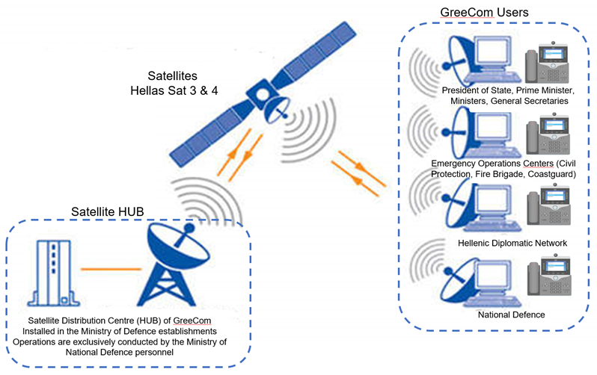

APPENDIX C: Preliminary GreeQCI Architecture
Simplified system architecture of the National QCI of Greece called GreeQCI currently under development under the EuroQCI initiative.
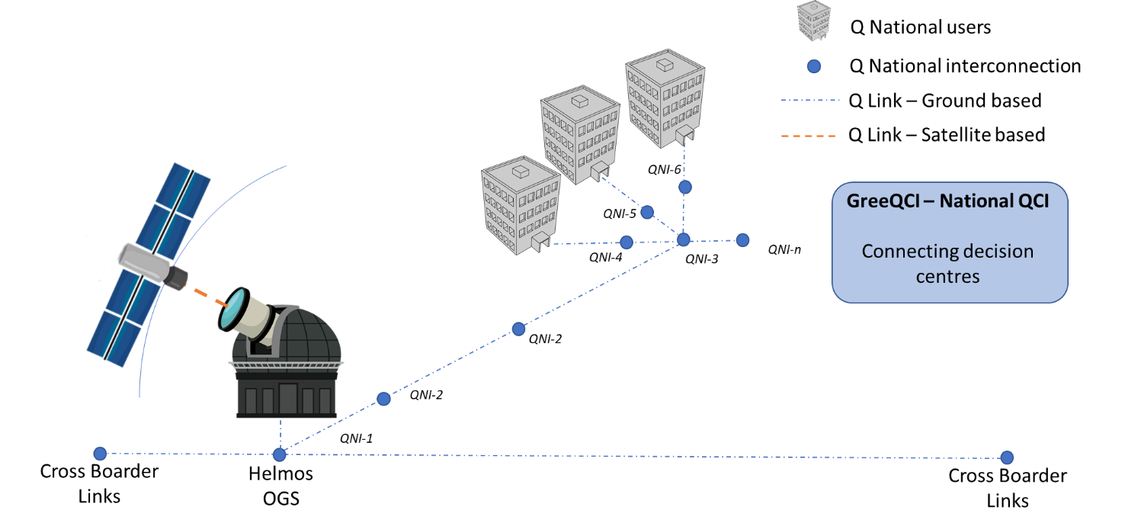
In 2022 the proof of feeder link concept is expected. The Quartz & QKD Sat missions are expected to be connected on Helmos OGS by 2023. The FOLC2 on Arabsat BADR-8 is also expected to be connected by 2023.
“Aristarchos”, the largest telescope of southeastern Europe, is one of the largest national research developments of the last decades in Greece and it is anticipated to promote Greek astronomy in the European and International research arena.
Helmos Observatory is situated on “Neraidorachi”, a mountaintop of the Helmos mountain chain in the Peloponnese, at an altitude of 2340 m above sea level, 220 km northwest of Athens. This site is one of the darkest places in continental Europe
Helmos Observatory hosts the modern “Aristarchos” telescope. “Aristarchos” is an optical telescope designed and manufactured by the German company Carl Zeiss GmbH. The main characteristic of this telescope is its 2.28 m mirror which, combined with the super-sensitive detectors that the telescope is equipped with and the excellent atmospheric conditions of the site, makes it a very valuable tool for observing astronomical objects, even very faint and very distant objects located in the outskirts of the Universe.

APPENDIX D: Digital Transformation Strategy 2020-2025: Space as an enabler for digital transformation
The basic intervention of the Digital Transformation incorporated a series of actions and projects. Those related to space are:
- Development of the Micro-Satellite Project (p.66). This project is an important step for the materialisation of the strategy of Greece for the utilisation of space technologies and applications and their uptake in the National economy. It includes the development of a microsatellite constellation that will cater application for telecommunications and earth observation for their use in governmental satellite services, cartography, maritime, precision agriculture, topography, and urban planning. The micro-satellite project is designed to be using the Fibre in the Sky – EuroQCI, with target the holistic provision of secure telecommunication services. Additionally, the project of microsatellites will support the application and services for search and rescue, boarder control, national security, civil protection. The development of the microsatellite system (space and ground) is expected to strengthen the capabilities of the Greek high tech industry. The project is expected to increase the availability, security and authentication of governmental communication networks. In parallel, it will provide high speed connectivity in remote areas taking into consideration of CSR 3 to 2020. Additionally, the framework of development of the micro-satellites is part of the EU GovSatcom, EuroQCI and Connectivity announced by the European Union on 15 July 2020.
- Fibre in the sky and ground infrastructures (p.67). Greece has already taken actions in order to be present in the next generation of secure communications. The programme is part of the broader initiative of the European Union Quantum Communication Infrastructure (EuroQCI) and Greece has secured the development of the first in Europe Optical Ground Station (OGS) for communications in the Observatory of Helmos in cooperation with the European Space Agency (ESA). The QCI initiative aims to create a secure, high-speed communication system that with the use of quantum encryption technology will protect the European Union’s economy from cyber-risks.
- GOVSATCOM- GreeCom (p.67). Greece has an operational Governmental Satellite Communications System that connects the country's decision centers with voice and data services, with the aim of ensuring seamless and continuous communication of critical government services even in times of crisis. The operation of GreeCom will be expanded and supplemented with the possibilities of secure communications that will be provided by the work of microsatellites and Fiber in the sky.
- Upgrade of the Hellenic Copernicus Collaborative Ground Segment (p.69). Development of urban infrastructure of big data for Earth observation and additional ones, that will allow access, utilisation and management of specialised information. In essence it is about the upgrade and futher development of the Hellenic Copernicus Collaborative Ground Segment https://sentines.space.noa.gr/ aiming its operation as an information system in the areas of south east Mediterranean, Balkans and wider area. The operation of this service which allows the free and open access as well as obtaining the data of Copernicus with the geographical coverage mentioned above, is under the responsibility of the National Observatory of Athens in cooperation with GRNET which has infrastructures and internet connectivity network of high speeds. The aim is that this computational and connectivity infrastructure will develop to an open type and not as a monolithic closed system exchanging operational existing infrastructures in particular of the European Space Agency but also National (e.g. open data for the cadastre and civil protection).
- Applications of Secure Quantum Cryptography – EuroQCI (p.122). The European Union is investing in the development of European secure quantum communication infrastructure (EuroQCI) and for this aim it has set up the EuroQCI initiative, in which Greece engaged at the end of 2019. The main building blocks of the under development infrastructure, need modern storage facilities, logistics, incorporation of supercomputers of parallel processing and data pyramids and high speed interconnections with the Greek academic network of GEANT. The applications foreseen related to environmental management of ecosystems, organisation, maritime surveillance, climate change, and natural disasters as well as targeted applications for agriculture.
- National Experimental Infrastructure for the Quantum Key Distribution (QKD) (p.122). Taking onto consideration the international developments in the field of quantum computing and in particular with the technological progress that concerns Quantum Key Distribution (QKD), the fact that priority is given by the European Union and the large installed fibre infrastructure of GRNET, it is proposed that the current action targeting the development of a national experimental infrastructure in the frame of showcasing the related technologies, and which will facilitate following the related scientific developments of the research community of the country.

APPENDIX E: Preliminary GreeConnect Architecture
Simplified system architecture of the National building block of Greece called GreeConnect based on the ongoing discussions on the European secure connectivity initiative.
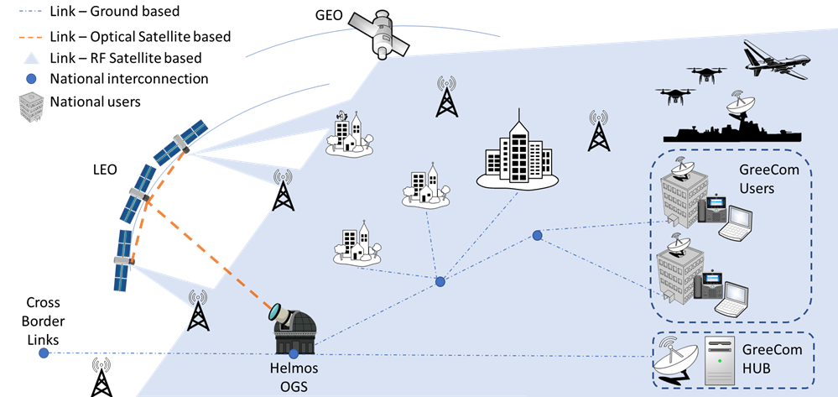

APPENDIX F: Preliminary user/data requirements for potential secondary payloads
Small satellites have become popular platforms for a wide variety of commercial as well as security and defense remote sensing applications, often using commercial components of the shelf (COTS). Constellations can provide temporal and geospatial sampling. Thus, technological developments in the field of small satellites constellations can be exploited through the construction of systems for national use, to obtain data in the optical spectrum with resolution of 1m or better and/or in Synthetic-Aperture Radar (SAR) and or Infrared (IR) for geodesy, hydrographic and geospatial data acquisition. Preliminary Technical Characteristics for Low Earth Orbit (LEO) or Medium Earth Orbit (MEO):
No. | Sensor type/  Είδος αισθητήρα | Pixel Resolution/  Διακριτική Ικανότητα | Geospatial accuracy/  Γεωμετρική Ακρίβεια | Revisit time/ Χρονική περίοδος επανεπίσκεψης | Spectrum/ Φάσμα
1 | Optical | ≤ 1m | ≤ 8m | Daily | Colour (PAN) & B, G, R, NIR, TIR
2 | SAR | ≈ 1m | ≈ 8m | Daily | -

Indicative (but not limited) Earth Observation services to be considered:
- Border monitoring
- Disaster detection and monitoring (e.g. forest fires, floods)
- Maritime monitoring
- Collection of Primary Data of Marine Surface Mapping for extracting surface currents (High Resolution Altimeter - At least 1Km resolution and measurement accuracy of at least 10cm).
- Detection of Surface Maritime Currents and Oil Spills (SAR with Discreet Capability & Geometric Accuracy Detectors of at least 100m).
- Data collection of Sea Surface Temperature at Night (Optical with Distinctive Capability & Geometric Accuracy Detectors of at least 2 km).
- Data collection for the extraction of Chlorophyll Concentration (Optical with Distinctive Capability & Geometric Accuracy of Detectors of at least 500m).

References
- https://mindigital.gr/archives/1512
- https://ec.europa.eu/digital-single-market/en/news/nine-more-countries-join-initiative-explore-quantum-communication-europe
- Harald Hauschildt, Carlo Elia, Andrew Jones, Hermann Ludwig Moeller, Josep Maria Perdigues Armengol, "ESAs ScyLight Programme: activities and status of the high throughput optical network "HydRON"," Proc. SPIE 11180, International Conference on Space Optics — ICSO 2018, 111800G (12 July 2019); https://doi.org/10.1117/12.2535935
- “GOVSATCOM and EuroQCI: Building blocks towards a secure space connectivity system”, European Commission Call for tenders DEFIS/2020/OP/0008, https://etendering.ted.europa.eu/cft/cft-document.html?docId=77642
- https://ec.europa.eu/commission/commissioners/2019-2024/breton/announcements/speech-commissioner-thierry-breton-13th-european-space-conference_en
- JRC Technical Report “A Secure Quantum Communications Infrastructure for Europe” published in July 2019: https://etendering.ted.europa.eu/document/document-file-download.html?docFileId=68917

Greek National Law, 2020 N4727.
https://ec.europa.eu/digital-single-market/en/news/nine-more-countries-join-initiative-explore-quantum-communication-europe
Detailed examples of use cases and services are described in the JRC Technical Report “A Secure Quantum Communications Infrastructure for Europe” published in July 2019: https://etendering.ted.europa.eu/document/document-file-download.html?docFileId=68917
“GOVSATCOM and EuroQCI: Building blocks towards a secure space connectivity system”, European Commission Call for tenders DEFIS/2020/OP/0008, https://etendering.ted.europa.eu/cft/cft-document.html?docId=77642
https://ec.europa.eu/commission/commissioners/2019-2024/breton/announcements/speech-commissioner-thierry-breton-13th-european-space-conference_en
“GOVSATCOM and EuroQCI: Building blocks towards a secure space connectivity system”, European Commission Call for tenders DEFIS/2020/OP/0008, https://etendering.ted.europa.eu/cft/cft-document.html?docId=77642
http://helmos.astro.noa.gr/
http://sci.esa.int/sci-ft/50124-technology-readiness-level/
Rough Order of Magnitude

